**Lecture 27 – Plant Anatomy and Growth**

* Angiosperms constitute 90% of all plant species.
* Plants have a hierarchical organization consisting of organs, tissues, and cells (Fig. 35.2)
  + ( ): a group of cells with a common function, structure, or both
  + ( ): several types of tissues that together carry out particular functions
    - ( ), ( ), ( )
  + Organ system
    - ( ) system: roots
    - ( ) system: stems and leaves
* Roots provide anchor, absorb minerals and water, and store carbohydrates
  + ( ) (support): one main vertical root, giving rise to lateral roots (branch roots)
  + ( ) (absorption): short-lived, constantly replaced, thin, tubular extension of root epidermal cells
    - Root hairs provide ( ) to maximize water absorption
    - Root hairs: epithelial projections (not an organ), facilitate water absorption
* Modification of roots
  + Some species have evolved storage roots for storing food or water
    - Examples:
  + Aerial roots are roots above ground
    - Examples: ( ): support, gather nutrients

( ): O2 absorption in

“water-logged” habitats

* Stems consist of an alternating system of ( ) and ( )
  + Stems conduct ( ) and ( ) and provide ( )
  + ( ): where leaves are attached
  + ( ): segments between nodes
  + ( ): forms lateral shoot (i.e. branch)
  + ( ): causes elongation of young shoot
  + There are many modifications of stems in plants
    - Examples: ( ), found in roses

( ), underground storage stem as in potato

( ), underground stem as in ginger

( ), horizontal stem, as in strawberry

* Leaf is the main site for ( ) and ( )
  + Consists of axillary bud (stipule), petiole, vein, midrib, blade
  + There are many modifications of leaves in plants
    - Examples: ( ), store water and food as in aloe

( ), attract pollinators as in bougainvillea

( ), protective modification as in cactus

* There are three tissue systems in each plant organ. Tissue system is a functional unit connecting all of the plant’s organs. (Fig. 35.8)
  + ( ): Outer protective covering
    - Nonwoody plants (and young plants)
      * ( ): a layer of tightly packed cells
    - Leaves and stems
      * ( ): a waxy coating, prevents water loss
    - Woody plants
      * ( ): protective tissue, replaces epidermis in older regions of stems and roots
  + ( ): Long-distance transport of materials between roots and shoots
    - ( ): conduct water and mineral upwards from roots into the shoots
    - ( ): transport sugars from where they are made to where they are needed
    - ( ): collective term for vascular tissue of a root or stem (arrangement varies)
  + ( ): Neither dermal nor vascular. Ground tissue system include specialized cells for storage, photosynthesis, and support.
    - ( ): internal to vascular tissue
    - ( ): external to vascular tissue
* Leaves contain three tissue systems (Fig. 35.18)
  + Dermal:
  + Vascular:
  + Ground:
* Stems contain three tissue systems (Fig. 35.17)
  + Dermal:
  + Vascular:
  + Ground:
* Roots contain three tissue systems (Fig. 35.14)
  + Dermal:
  + Vascular:
  + Ground:
* Plants grow throughout life
  + Plants undergo ( ) growth (growth occurs throughout life)
    - annuals, biennials, perennials
  + Plants have perpetually embryonic tissues called ( )
  + Primary growth ( )
    - ( ) (tips of roots/shoots, axillary buds of shoots)
  + Secondary growth ( )
    - ( ) (vascular cambium and cork cambium)
* Primary and secondary plant growth

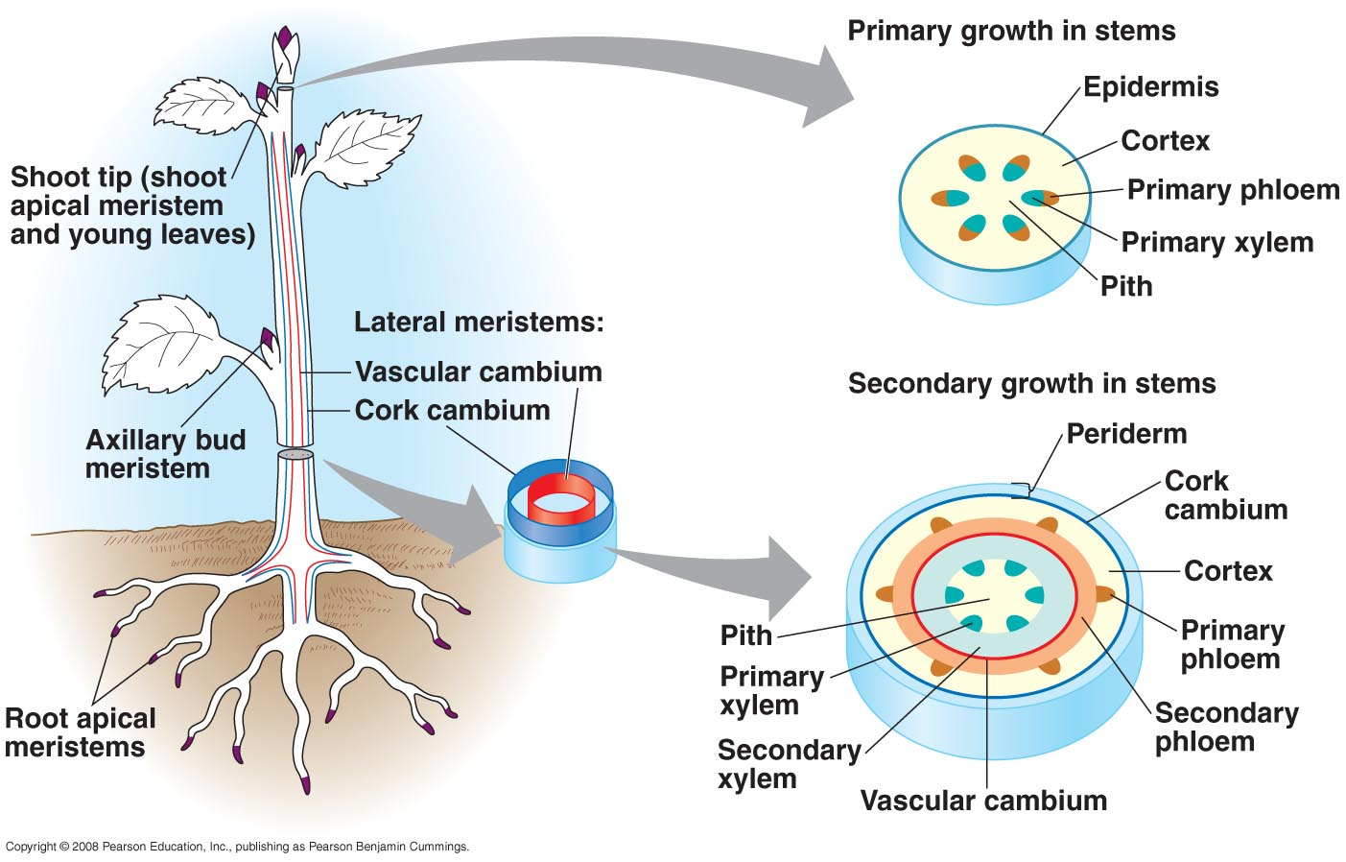

* Primary growth of roots occurs behind the tip in three overlapping zones of cells (Fig. 35.13)
  + ( ): protects apical meristem; secretes a polysaccharide slime that lubricates soil
  + Zone of ( ): root apical meristem and its derivatives
  + Zone of ( ): where most of the growth occurs as root cells elongate
  + Zone of ( ): where cells complete their differentiation and become distinct cell types
* Primary growth of shoots occurs at apical meristem (Fig. 35.16)
  + Shoot apical meristem is a dome-shaped mass of dividing cells at the shoot tip
  + Leaves develop from ( )
  + Shoot elongation is due to lengthening of internode cells below the shoot tip
* Secondary growth consists of the tissues produced by the ( ) and

( ) (Fig. 35.19, know this figure)

* ( ) cambium adds secondary xylem (interior) and phloem (exterior)
* ( ) cambium produces a tough, thick covering
* As a tree ages, the older layers become non-functional
  + ( ): older layers of secondary xylem (non-functional)
  + ( ): newer layer of secondary xylem
  + Older secondary phloem is sloughed off as size increases